- Battery
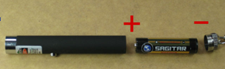
1 x AAA (Not Include)

WARNING:
1. Never look directly into the laser beam. Never point a laser beam at a person. Do not aim the laser at reflective surfaces.
2. Not for children under 18 years,Recommended for ages 18 and older.

